H.T No
Regulations:
A18


Sreenidhi Institute of Science and Technology
(An Autonomous Institution)
Code No: 7HC06 Date: 29-Dec-2018 (FN)

B.Tech I-Year I-Semester End External Examination, Dec-2018/Jan-2019 (Regular)
ENGINEERING MATHEMATICS - I (CIVIL, EEE, ME and ECE)

Time: 3 Hours Max.Marks:75

Note: a) No additional answer sheets will be provided.
b) All sub-parts of a question must be answered at one place only, otherwise it will not be valued.
c) Missing data can be assumed suitably.

Part - A Max.Marks:25

Answer all QUESTIONS.

1. | Find the Radius of curvature for the curve 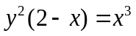 at(1,1). | [3M]
2. | Verify Lagrange’s mean value theorem for ƒ(x) = x(x-2)(x-4) in (0,1/4). | [3M]
3. | Test the convergence of the series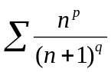 | [3M]
4. | If F = 3xyz² i +2 xy³ j –x²yz k , then find div F at (1,2,4). | [3M]
5. | Find the Rank of the matrix = 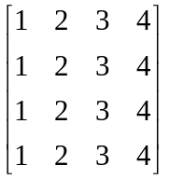 | [3M]
6. | If 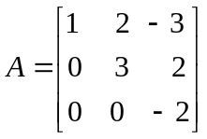, then find the Eigen values of matrix 3A² - 2I . | [2M]
7. | Evaluate 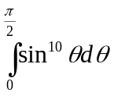 | [2M]
8. | Write Dirichlet conditions in Fourier series. | [2M]
9. | Define symmetric and skew symmetric matrices and give examples. | [2M]
10. | Expand Maclaurin’s series of log(1+x). | [2M]
Part – B Max.Marks:50
ANSWER ANY FIVE QUESTIONS. EACH QUESTION CARRIES 10 MARKS.

11. | a) | Show that the evaluate of the ellipse x = a cosθ, y = b sinθ is  (ax)^{2/3} +(by)^{2/3} = (a²-b²)^{2/3}. | [5M]
 | b) | Evaluate 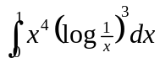. | [5M]
12. | a) | Discuss the applicability of Rolle's theorem for f(x)= 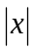in the interval(-1,1) | [5M]
 | b) | Verify Cauchy mean value theorem for ƒ(x) = sinx ; g(x) = cosx in the interval (0, ). | [5M]
13. | a) | Test the convergence of the series Test the convergence of the series  1+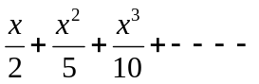 | [5M]
 | b) | Find the Fourier series of the function 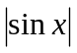 where -<x< | [5M]
14. | a) | Find the directional derivative of a function xy+yz+zx in the direction of 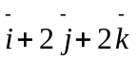 at the point (1,2,0). | [5M]
 | b) | Find Curl 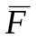 where = 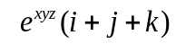 at the point (1,2,3) | [5M]
15. |  | Find the values of p and q such that the equations x+2y+3z=6, x+3y+5z=9, 2x+5y+pz=q have  (i) No solution (ii) Unique solution (iii) Infinite solutions. | [10M]
16. |  | State Cayley-Hamilton theorem and verify for the matrix A = 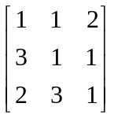 | [10M]
17. |  | Find the Fourier half range sine and cosine series of f(x)= sinx in the interval (0, ). | [10M]
18. | a) | Verify Lagrange's mean value theorem for the function 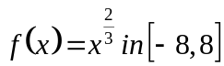. | [5M]
 | b) | Find the maximum and minimum values of x³ + y³ - 3axy. | [5M]

-- 00 -- 00 –

